APT Project: Monroy Sales

Guide 2. APT Project Development
Capstone Course

1. Summary of APT Project Progress
Below, you will find different fields that you must complete with the requested information.

APT project progress summary | Ventas Monroy is an inventory management and control software solution developed for a real company that markets local fruits—olives, peanuts, and candies—and operates as a wholesaler with its own warehouse. The project stems from a specific problem: the company already issues electronic shipping documents to the Internal Revenue Service, meaning its tax documentation is digitized, but it continues to manage its inventory manually, using paper records and spreadsheets.  During Phase 2, the team moved from design to development. The gathering and analysis of functional and non-functional requirements with the client was completed, and a fully functional web application consisting of two layers was implemented. The customer-facing layer includes the online store with a product catalog, category filtering, a shopping cart with subtotal, shipping, and total calculations, and user authentication via user credentials or an external provider. The administration layer ( back office ) includes a summary dashboard with real-time indicators—active products, available units, inventory valuation, and stock alerts—, a product management system with SKU code, category, price, stock levels, and status (available, low stock, out of stock), an order management and tracking module with workflow statuses (pending, preparing, shipped, delivered), and a manual form for recording incoming and outgoing transactions with a reason for each transaction.  The specific objectives of requirements gathering, functional definition, and development of the user interface and business logic were met. The specific objective of designing and implementing the data model is ongoing: the structure of products, inventory, and transactions is defined at the functional level, but the formal entity-relationship diagram and the persistence of batch and expiration date control are still pending. Testing, documentation, and closeout activities have not yet begun, as they depend on the completion of the integration phase.  The progress is therefore substantial in the application layer and partial in the data layer, which defines the priorities of the final stage of the project.
Goals | The objectives defined in Phase 1 are not modified. They are reported with their status of compliance at the close of this phase.  General objective: To develop and implement Ventas Monroy, a comprehensive IT solution for small and medium-sized businesses that sell peanuts, olives, and confectionery. This solution will automate the recording of incoming and outgoing merchandise, ensure traceability of batches and expiration dates, and optimize inventory management. Status: Under development, with automated recording implemented and batch traceability pending.  Specific objective 1 — Gather and model the functional and non-functional requirements of the business. Status: Completed. This was accomplished through interviews with the client and a review of their actual operational documentation.  Specific Objective 2 — Design the software architecture and data model that supports stock, batches, and expiration dates. Status: Partially completed. The architecture is defined and implemented; the formal data model and its persistence are in progress.  Specific objective 3 — Build the user interface and business logic for administrators and operators. Status: Completed. This is evidenced in the eight attached screenshots, both in the store and in the administration panel.  Specific objective 4 — Manage and plan the project life cycle. Status: Completed and in continuous execution, with assigned roles, current Gantt chart and monitoring of the work plan.  Specific objective 5 — Validate and test the solution using unit, integration, and security tests. Status: Not started. Activated in the closing phase.
Methodology | The methodological framework defined in Phase 1 is maintained: an agile approach based on Scrum, adapted to the course's time constraints. Its specific implementation is detailed below.  Framework. Scrum is adopted according to the Scrum Guide (Schwaber and Sutherland, 2020), complemented by the requirements engineering and life cycle practices described by Sommerville (2011) and Pressman (2010). This choice is based on the fact that the client's requirements are known in their core but are susceptible to refinement, a scenario in which an iterative and incremental framework is more appropriate than a sequential model.  Iteration duration . We work with one - week sprints , aligned with the course sessions. Each sprint produces a verifiable functional increment of the system.  Roles. The Product Owner role is filled by the project manager, as they are the counterpart with direct access to the client, and they prioritize the backlog and validate the increments. The facilitator or Scrum Master role rotates among the team members. The development team consists of the four members, with the specializations indicated in the work plan.  Ceremonies. Sprint planning at the beginning of each weekly session , in which backlog items are selected and responsibilities are assigned; a brief synchronization meeting during the week via remote channel to detect blockages; review of the increment at the end of the sprint, comparing what was built with the acceptance criteria ; and a retrospective at the end of each phase block, from which the adjustments reported in this report emerged.  Artifacts. Product backlog with the functional and non-functional requirements gathered from the client; weekly sprint backlog; and versioned software increment in the project's Git repository.  Definition of Terminated ( Definition (of Done). An item is considered finished when it meets its functional acceptance criteria , is integrated into the main branch of the repository, does not introduce regressions in previous modules , and has associated graphical or documentary evidence.  Life cycle phases on which sprints operate : Requirements analysis and engineering ; design architectural and data; implementation and development; and testing and deployment, the latter pending start.  Support tools. Distributed version control with Git and a remote repository on GitHub; Draw.io for data modeling; Figma for interface prototyping; Visual Studio Code as the development environment; and tracking progress on the Gantt chart and work plan of this report.  Methodological adjustment introduced in this phase. The planned sequence was altered in practice : the implementation of the presentation layer progressed before the data design was finalized . The team maintains the methodological framework but reorders the backlog for the remaining section to prioritize the structural layer, on which the functionalities not yet implemented depend.
Evidence of progress | Evidence 1: Main Interface    Main store screen, showing the header with search bar, login, shopping cart, main banner with action button that redirects to the catalog.  Justification: Demonstrates compliance with the milestone of the frontend and user interface, leaving the initial navigation and basic visual structure operational for the client.  Evidence 2: User Authentication    Screenshot of the user login window, which allows authentication using traditional credentials (email and password) or integration with external providers such as Google.  Justification: Shows progress in the implementation of user management and login, a key requirement to enable order tracking, account customization, and the purchase process.  Evidence 3: Product catalog and filtering by category    Screenshot of the product catalog section, showing the card system for displaying items with their respective images, prices, brief descriptions and a quick add button, as well as filters by category.  Justification: Evidence demonstrates the implementation of the store's core module, proving that the product query, dynamic rendering, and quick interaction for adding items to the shopping cart are developed and functional.  Evidence 4: Shopping Cart  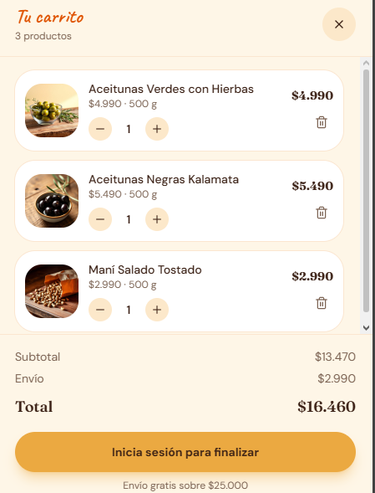  Screenshot of the shopping cart dropdown window ("Your Cart"), where the list of selected products is displayed, interactive controls to increase or decrease quantities, option to remove items, automatic breakdown of the subtotal, shipping cost and calculation of the total to pay, along with a guided button to finalize the purchase process.  Justification: Demonstrates the development of the business logic and the overall state of the application, confirming that the addition, modification, and real-time financial calculation of items within the order are fully implemented and operational.  Evidence 5: Administration ( dashboard ) Inventory Management  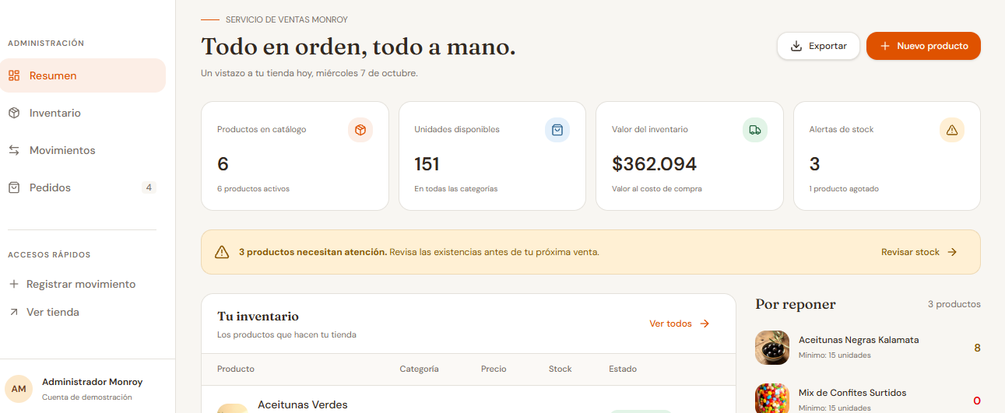  Capture of the administration view ("Summary"), which includes a side navigation menu (Inventory, Movements, Orders, Quick Access), real-time key metrics ( KPIs : active products, available units, inventory valuation and stock alerts), a critical notification system, buttons to export data or register new products, and a prioritized section of items to be replenished.  Justification: It demonstrates the complete development of the internal management module ( back office ), showing that the platform is not just a visual catalog, but a comprehensive system capable of consolidating stock data, managing orders, and facilitating the administrator's decision-making.  Evidence 6 Product Inventory  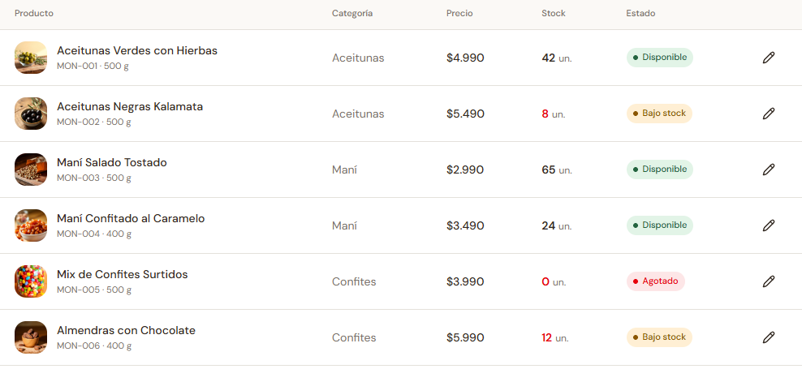  Capture of the complete inventory view in table format, where the registered items are listed with their respective SKU code (e.g., MON-001), image, category, price, units in stock, status labels according to stock level (Available, Low stock, Out of stock) and a quick action button for editing each record.  Justification: Demonstrates the development of detailed catalog management from the administration module, confirming the correct implementation of basic maintenance operations (CRUD: Read, Edit and Update products).  Evidence 7 Order Management and Tracking  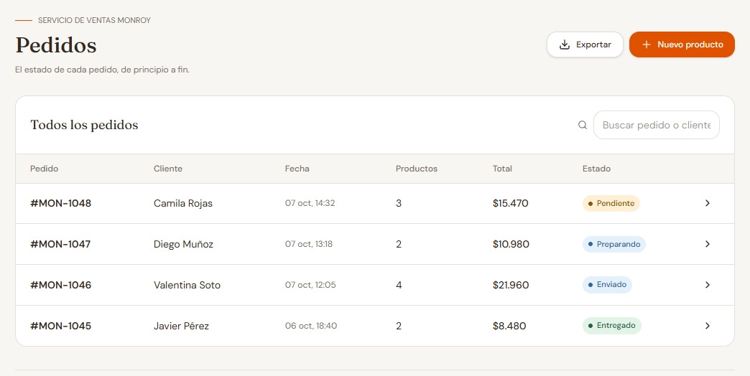  Screenshot of the order management view ("Orders"), showing the table with the history of purchases made, including order identifier (e.g., #MON-1048), customer, date and time, quantity of products, monetary total, dedicated search bar and dynamic labels of the delivery flow (Pending, Preparing, Shipped, Delivered).  Justification: It demonstrates the development of operational sales traceability in the back office , confirming that the complete purchase processing cycle — from the initial customer order to the final dispatch status — is implemented and dynamically controlled.  Evidence 8 Manual Stock Movement Record  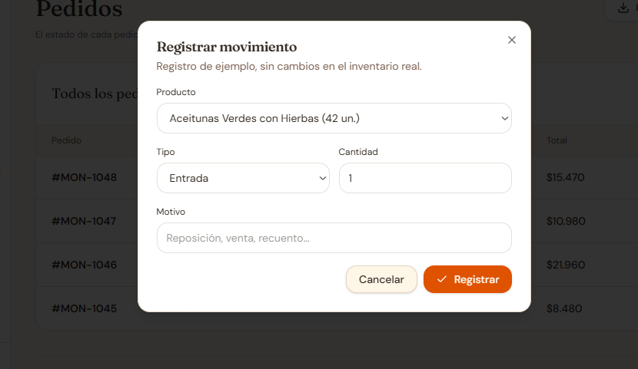  Capture of the pop-up form ("Register movement"), which allows the administrator to select a product from the catalog, define the type of transaction (Entry or Exit), enter the quantity of units and specify the reason for the movement (replenishment, count adjustment, shrinkage, etc.).  Justification: Demonstrates the implementation of transactional inventory control and real-time stock adjustments, ensuring that the system allows for audits, traceability, and manual entry of merchandise outside the automated sales flow.  Evidence 9 chatbot  Screenshot of the interactive assistance pop-up window ("Moni"), showing the automated real-time conversation flow, including targeted welcome greetings, quick options buttons filtered by user preference, suggested responses based on the product catalog with explicit price indication (e.g., Candied Peanuts at $3,490) and weight formats (400 g), a dedicated bottom text box for entering free questions, and a guided query submission button.  Justification: Evidence of the implementation of the automated customer service module in the sales layer, confirming that the initial support channel — focused on intelligent product recommendations by category and quick resolution of frequently asked questions — is integrated and operational for the end user.  Evidence 10 Database Model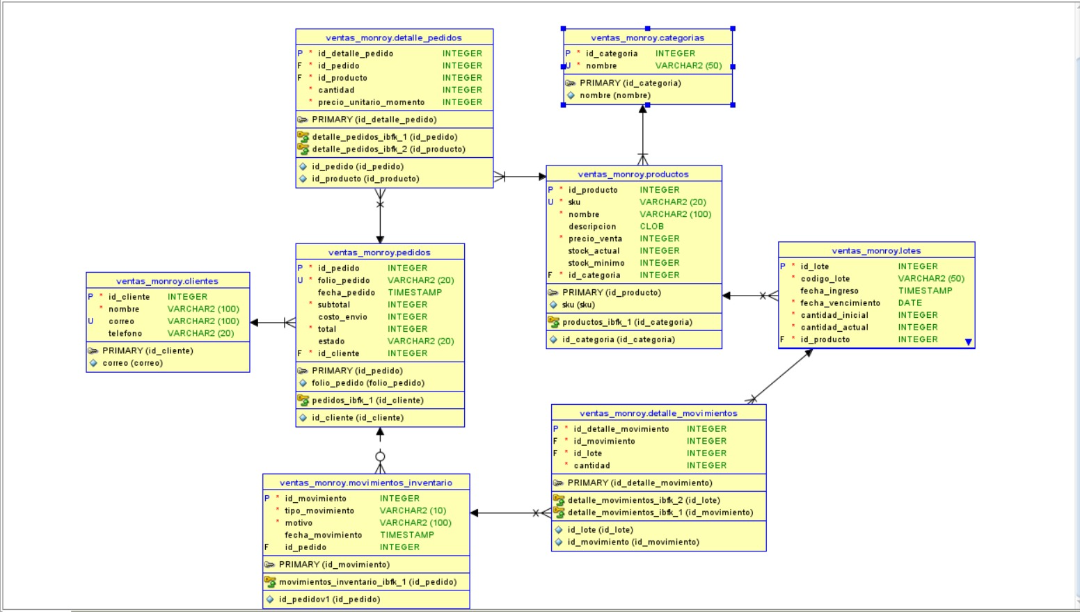  - Products and Categories: Products are organized into groups (for example, the Olives or Nuts category). A group has many products, but each product belongs to only one group.  - Products and Batches: Since food is sold, products are stored by "batches" to track their expiration dates. A single product may have several batches in storage (because they arrived on different dates), but each batch corresponds to only one type of product.  - Customers and Orders: A customer can place many orders on the website over time, but each order belongs to a single customer.  - Orders and their Details: When someone makes a purchase, a general order is generated (with the date and total amount due). This order opens into a "detail" section that shows the line items with the exact products purchased and how many units of each.  - Inventory Control (Movements): Every time something is sold online or damaged products are discarded (shrinkage), the system records an "Outgoing Movement." If new merchandise arrives, an "Incoming Movement" is recorded. These movements automatically adjust the stock levels in the corresponding batches.  Quality assurance for the APT Project. The quality of the progress was safeguarded through best practices of the discipline: version control with Git and a centralized repository on GitHub (https://github.com/ismaelcabrera/VENTAS-MONROY), where evidence from each phase is stored in a folder structure organized by phase and type of evidence; prior specification of requirements validated directly with the client before coding; user interface design focused on operational usability, with explicit visual stock statuses (available, low stock, out of stock) that reduce human error; use of standardized SKU coding for unique product identification; and cross-review among team members before incorporating each module.  Scope and declared limitations of the evidence. For methodological transparency, it is noted that the stock movement record currently operates on sample data and does not yet persist to the actual inventory, as indicated in the interface of evidence 8. Likewise, the inventory views do not yet include the batch and expiration date columns, as this depends on the finalization of the data model. Both limitations have been identified, do not compromise what has already been built, and constitute the declared priorities for the final stage of the project.
2. Monitoring of the Work Plan
Carefully examine your work plan, focusing especially on the progress status and adjustments column.

Work Plan
Competence or units of competence | Activities | Resources | Duration of the activity | Responsible | Observations | Progress status | Settings
Requirements Engineering / IT Project Management | Requirements gathering and analysis | Computers, interview forms, Google Docs / Notion , internet | 3 weeks | Javier Monroy | Facilitator: direct and continuous access to the client, which allowed for validating requirements with real-world information and reviewing their operational documentation. Challenge: coordinating the client's availability with the team's schedules. | Filled | No adjustments were made. The activity was completed within the planned timeframe (3 weeks, August).
Database Management / Software Design | Data modeling and architecture | Draw.io, Figma , Development IDE | 3 weeks | Victor Iriarte | Challenge: Defining the logic for products, batches, stock levels, and expiration dates proved more complex than anticipated, as this structure governs the rest of the system. Facilitator: Well-defined business rules from the previous phase. | Delayed | Adjusted. The deadline is extended and a second team member is added: the project manager joins the data architect to resolve the issue. The formal entity-relationship diagram, incorporating the batch and due date entities, is committed as a deliverable and will be uploaded to the repository.
Software Design and Development / Multiplatform | System programming and integration | VS Code, Git/GitHub, database, development frameworks | 8 weeks | Ismael Cabrera | Facilitator: Use of open-source tools and version control with Git. Difficulty: Integration between the database, business logic, and interface requires a closed data model, which created a dependency on the previous activity. | In progress | Adjusted. Core business functionalities (catalog, shopping cart, authentication, inventory, orders, and transactions), which are already operational, were prioritized. The remaining section is being reorganized to connect data persistence before incorporating new functionalities.
Quality Design and Development / Project Management | Software testing, documentation, and closure | Testing environment, manual template, Trello/Gantt | 4 weeks | Ignacio Ceron | Challenge: The activity was contingent upon the completion of development, concentrating the risk at the end of the timeline. Facilitator: Stable modules already exist on which validation can begin. | Not started | Adjusted. The start date is brought forward: the design of the test plan and validation cases begins now on the stable modules, without waiting for the end of development, to avoid the accumulation of work at the close-up.
Resolve systemic vulnerabilities / Perform certification testing | Application security assurance and testing | Testing environment, OWASP Top 10 checklist , Git repository | 3 weeks | Ignacio Cerón, with criteria defined by Javier Monroy | Facilitator: The system manages real business data, allowing for the prioritization of specific risks. Challenge: Security must be considered from the design stage and not added at the end. | Not started | New activity, incorporated in this phase. It responds to the competency of resolving systemic vulnerabilities and covers the authentication already implemented, access control by differentiated roles (administrator, warehouse worker and salesperson) and the audit log of inventory movements.
Manage IT projects / Develop a software solution | Repository management and traceability of individual contributions | Git/GitHub, naming convention and folder structure by phase | Transversal (until closing) | Javier Monroy | Challenge: Up until now, uploads have been concentrated among a few members, so the history doesn't accurately reflect each person's contribution. Facilitator: The repository is already structured by phases and types of evidence. | In progress | This is a new activity, incorporated in this phase based on teacher feedback. It includes four tasks: (1) uploading the source code for the frontend and backoffice that support the presented screenshots; (2) uploading the data model and the database creation script; (3) deleting the "a" marker files and the empty file from the Program folder, replacing them with actual content; and (4) having each member record their own contributions through commits identifiable with descriptive messages, so that the fairness of the work can be verified in the history.

3. Adjustments based on monitoring
Delve deeper into the observations of your work plan. Analyze the planned activities and identify which aspects facilitated or hindered the plan's execution. Explain how you addressed and/or will address the obstacles. Finally, indicate the adjustments you made to the work plan based on this analysis.

Factors that have facilitated and/or hindered the development of my work plan:

Facilitating factors. The first and most crucial has been having a real and accessible client: the project manager maintains direct contact with the company, which allowed for gathering requirements based on verifiable information rather than assumptions, and identifying the finding that defines the system's scope—the coexistence of several batches of the same product at different prices within the same shipping document. The second is the precise definition of the problem, objectives, and functionalities from Phase 1, which avoided scope ambiguities. The third is the stability of team roles throughout the entire phase. The fourth is the availability of standard and open-source tools for development, modeling, documentation, and version control.

Factors that have hindered development. The first is time availability: three hours of coursework per week are insufficient given the technical demands of an inventory system, forcing students to rely on independent work and coordinate four different schedules. Action taken: organizing into weekly blocks with a verifiable objective each week and monitoring progress in each session, instead of measuring progress based on perception.
The second issue is the complexity of batch and expiration date control, which is greater than anticipated, as it requires finalizing the data structure before programming on it. Action taken: reinforce the task with a second team member and commit the entity-relationship diagram as a verifiable deliverable in the repository.
The third error is a prioritization mistake that the team acknowledges: they progressed first on the visible layer of the system and then on the structural layer, which reversed the methodological sequence and left the data model lagging behind. The functional progress of the interface masked this delay. The action taken was to reverse the prioritization criteria for the final stage and address data persistence first.
The fourth issue is the undervaluation of evidence recording as an integral activity. Documentation and repository management were treated as a closing procedure rather than a planned task. Action taken: to incorporate repository management as a formal activity within the work plan, with an assigned person responsible, and to document it concurrently with development.

Activities adjusted or eliminated:

No activities were removed from the work plan, nor were the objectives agreed upon in Phase 1 modified. The overall structure and scope remain the same. The adjustments made are sequential, reinforcing, and incorporative, and they address the difficulties described and the feedback received from the instructor.

Adjustment 1 — Data Modeling and Architecture: Strengthened activity. The project manager is added alongside the data architect, and the entity-relationship diagram, including batch and due date entities, is committed as a deliverable in the repository. Justification: This activity was blocking the others and concentrating the risk on a single person.
Adjustment 2 — Programming and Integration: This activity has been adjusted in scope due to prioritization. Efforts have been concentrated on core business modules, which are currently operational, and the incorporation of secondary functionalities is being postponed until data persistence is connected. Justification: to ensure a functional and consistent product rather than a lengthy and incomplete one.
Adjustment 3 — Software testing: activity brought forward. It is no longer contingent on the completion of development and now begins on the stable modules. Justification: to avoid the accumulation of critical work in the final weeks, which was the main risk identified in the schedule.
Adjustment 4 — Security Assurance and Testing: New activity. It is formally incorporated into the plan to cover the competency of resolving systemic vulnerabilities, considering that the system manages sensitive client business information. Justification: Security was implicit in the project but was not listed as an evaluable activity.
Adjustment 5 — Repository Management and Contribution Traceability: New activity. This is being added to upload the system's source code and ensure that each member records their contributions through identifiable commits . Justification: The repository currently contains documents and screenshots, but not the program itself, and the history does not accurately reflect each member's participation.

Activities that have not started or are delayed:

Delayed Activity — Data Modeling and Architecture. It was supposed to be completed in September but is still ongoing. The reason is twofold: the actual complexity of batch and expiration control was greater than estimated, and the team prioritized advancing the presentation layer, which postponed the structural layer. Strategy: a second team member has been added, the entity-relationship diagram uploaded to the repository has been established as a verifiable deliverable, and its completion has been set as a prerequisite for adding further functionalities.

Activity not started — Software testing, documentation, and closure. It has not started because it was planned as dependent on the completion of development. Strategy: Its start is being brought forward. The design of the test plan and validation cases begins immediately on the already stable modules —authentication, catalog, shopping cart, inventory, and transaction log— and the documentation is being developed in parallel with development, not at the end.

Activity not yet started — Security assurance and testing. This is a new activity incorporated in this phase, so it has not yet begun. Strategy: It is executed in conjunction with software testing, taking advantage of the fact that authentication is already implemented and that role-based access control can be built on top of it.

None of these activities compromise the achievement of the overall objective, provided that the data model closure is completed within the agreed timeframe. This is the project's main risk and is monitored weekly by the project manager.

4. Declaration and justification of the extension of scope
Explicit statement of the difference between the scope committed to in Phase 1 and the solution actually built, with its technical and business justification.
Statement. The scope committed to in Phase 1 corresponded to an internal inventory control and management system, geared towards the administrator and warehouse staff. The solution built during Phase 2 incorporates, in addition to this internal module, an online sales layer for the end customer: a public catalog with category filtering, a shopping cart with automatic calculation of subtotal, shipping, and total, and user authentication. The team explicitly declares this expansion of scope, which was not considered in the original project formulation.

Technical justification. The decision was not based on aesthetics but on functionality. The overall objective of the project is to automate the recording of incoming and outgoing merchandise. Incoming goods come from suppliers and are recorded manually, while outgoing goods originate from sales. Without a sales channel integrated into the system, each outgoing item would still have to be entered manually, which is precisely the problem the project seeks to eliminate. The online sales layer allows outgoing items to be generated as a result of a recorded transaction, rather than subsequent data entry, thus closing the traceability loop between sales and inventory.

Business Justification. The client's declared business activity is the wholesale purchase and sale of domestic produce. During the requirements gathering phase, it was found that the company already operates with electronic tax documentation in accordance with Exempt Resolution No. 99 of 2014 from the Internal Revenue Service and Law No. 19,983 regarding the enforceability of invoices, but that order taking and inventory control remain manual processes. Formalizing order taking in the system reduces transcription errors and provides the administrator with a sales record that can be compared with the inventory.

Cost of the decision. The team acknowledges that this expansion had a real cost: the effort dedicated to building the sales layer consumed time that was planned for finalizing the data model, which explains the reported delay in that activity. This is the main cause of the schedule deviation and is recorded as such in the work plan monitoring.

Decision made for the final stage. The online sales layer will remain frozen in its current state and will not receive any new features. All remaining effort will be dedicated to finalizing the data model with the batch and expiration date entities, implementing their persistence, and running validation tests. This will realign the project with its overall objective, maintaining the sales layer as the mechanism that drives outbound transactions.
5. Response to teacher feedback
Observations received in the formative evaluation of the progress report and adjustments adopted by the team in response to each one.
The team received formative feedback on the first version of this report. Each observation and the adjustment made are detailed below.

frontend and backoffice source code supporting the presented screenshots to the repository. Adjustment: The activity "Repository Management and Traceability of Individual Contributions" is incorporated into the work plan, with an assigned responsible party and a cross-cutting nature until project closure. This includes publishing the source code for both layers in the project repository.

Observation 2 — Upload the data model and the database script. Adjustment: The entity-relationship diagram, incorporating the batch and expiration date entities, along with the database creation script, is committed as a verifiable deliverable. Both are associated with the data modeling activity, which is reinforced with a second team member.

Observation 3 — The Program folder contains an empty file, and the Phase 2 folders contain only bookmark files. Adjustment: The bookmark files and the empty file are removed and replaced with the actual system content and a folder structure documented in the repository's README file.

Observation 4 — Clarify whether the presented data is for demonstration purposes. Adjustment: An explicit statement of scope and limitations is included in the evidence section. It is noted that the stock movement log currently operates on sample data and does not persist on the actual inventory, as indicated in the interface itself, and that the inventory views do not yet include the lot and expiration date columns.

Observation 5 — Balance commits among the four team members. Adjustment: Each team member will publish their own deliverables using identifiable commits with descriptive messages, instead of centralizing uploads. The project manager will also record management documentation—minutes of client meetings and requirements specifications—which was not previously reflected in the history.

Observation 6 — Declare and justify the expansion of the scope to include an online store. Adjustment: Section 4 of this report is incorporated, where the expansion is explicitly declared and justified in technical and business terms, recognizing its cost on the schedule and setting the decision adopted for the final stage.

Observation 7 — Align the summary with the evidence. Adjustment: The progress summary was completely rewritten, now describing the modules actually implemented and supporting the eight attached pieces of evidence, and each specific objective is reported with its status of completion.

Observation 8 — Specify the methodology. Adjustment: The methodology section was reformulated to detail the adopted framework, the duration of the iterations, the roles, the ceremonies, the artifacts, the definition of done, and the support tools, instead of stating the approach in a general way.

Observation 9 — Incorporate citations and references. Adjustment: citations are incorporated into the body of the report and a bibliographic references section according to APA standards, which includes the methodological sources, the quality and safety standards used and the tax regulations applicable to the client's context.
6. Abstract
Executive summary of the progress report, in Spanish and English.
ABSTRACT (Spanish)

Ventas Monroy is an inventory management and control software solution developed for a Chilean micro and small business dedicated to the wholesale distribution of the country's fruits: olives, peanuts, and candies. The initial assessment identified a significant operational contradiction: the company issues electronic tax documentation to the Internal Revenue Service, but manages its inventory manually, resulting in outdated stock records, losses due to products nearing their expiration date, and a loss of profit margin because it cannot distinguish between batches of the same product purchased at different prices. The project's objective is to automate the recording of incoming and outgoing stock, guarantee traceability by batch and expiration date, and provide reliable information for decision-making. During this phase, a web application was implemented with a sales layer—catalog, shopping cart, and authentication—and an administration layer with real-time inventory indicators, a product management system with SKU coding, order management, and stock movement tracking. The work was developed using an agile approach based on Scrum, with weekly iterations and version control. The data model and validation tests are the remaining activities of the final stage.

ABSTRACT (English)

Monroy Sales is an inventory control and management software solution developed for a Chilean micro and small business that local wholesales produces: olives, peanuts and confectionery . The initial assessment revealed a significant operational contradiction : although the company already issues electronic dispatch documents to the national tax authority , it still manages its inventory manually . As a result , stock records are permanently Outdated products are lost​ when they approach their expiration date, and profit margin es eroded because batches of the same product purchased at different costs cannot be distinguished from one another .
The purpose of the project es therefore to automate the recording of incoming and outgoing goods , to guarantee traceability by batch and expiration date, and to deliver reliable information for managerial decision-making . During this phase , the team implemented a functional web application consisting of two Layers . The sales layer provides a product catalog with category filtering , a shopping cart with automatic subtotal and total calculation , and user authentication . The administration layer provides a dashboard with real-time inventory indicators , a product maintainer with SKU coding and stock status labels , order tracking with delivery states , and a form for recording stock movements .
The team adopted an agile approach based on Scrum, organized into weekly iterations and supported by distributed Version control. Requirements were gathered directly from the client rather than assumed , which allowed the team to define a realistic scope . It must be noted that the scope was extended beyond the original proposal , since an online sales layer was added so that outgoing stock movements are generated by an actual transaction instead of manual data entry . The data model and the validation testing stage remain as the pending activities for the final phase of the project .
7. Individual Conclusions (in English)
Individual conclusion — Javier Ignacio Monroy Silva, Project Manager. Each team member should include their own conclusion in this section.
Individual conclusion — Javier Ignacio Monroy Silva (Project Manager)

Leading this phase as project manager taught me that managing a software project es mainly a matter of making visible progress , and not only of making Our progress​ team built far more than I expected in a single phase : the sales layer , the authentication module, the catalog and a complete administration panel are all operational today . However , when I compared the plan against the schedule , I found that the data model was still unfinished , even though Item should have been closed in September. The reason was that the visible progress of the interface concealed the delay in the structural layer , and as the person responsible for monitoring the plan, I did not detect Item early enough .
The feedback we received confirmed This diagnosis from the Outside . We were told to upload the source code and the database script, to state clearly whether our data was demonstrative , to balance the contributions recorded in the repository , and to declare the extension of our scope . Every one of those observations pointed at the same underlying issue : we had been documenting what the system looked like instead of documenting how Item was Built for assessment purposes , and for professional purposes as well , work that leaves not verifiable trace simply does not exist .
Finally , I decided not to delegate the database entirely , even though Item es my weakest competence . A project manager who does not understand the data model of his own system cannot estimate deadlines or assess technical risk responsibly . Closing that gap is therefore not only a personal goal but a requirement of the role I agreed to take on .
8. Reflection (in English)
Individual reflection in English on the progress of the APT Project.
Reflection — Javier Ignacio Monroy Silva

Working with a real client has been the most valuable part of this project so far . When we reviewed the company's own dispatch documents , we found five different batches of the same product listed at five different prices per kilo within a single document . That single piece of evidence changed the way I understood the problem : the company was not losing money because Item lacked a website , but because Item could not tell which batch Item was selling , at what cost , or when Item would expire. Since then , every decision we have made about scope has been measured against that finding .
At the at the same time, this phase has shown me the distance between what a system looks like and what a system actually Our solutions​ application es visually complete and functionally convincing , yet the traceability requirement that justifies the whole project has not been implemented . Recognizing that Honestly , rather than presenting the interface as if Item were the The solution is in my view part of acting professionally . This es also Why we decided to freeze the sales layer and redirect the remaining effort towards the data model .
Finally , this phase confirmed my professional interest . The module I am most committed to delivering es the one dealing with access control, roles and audit records for every stock movement , because Item protects the client's commercial Information .​ security es the field I want to work in after graduation , and this This project has given me the first realistic opportunity to practice Item on a system that someone will genuinely use.
9. Bibliographic references
Sources cited in the report, in accordance with APA standards (7th edition).
Library of the National Congress of Chile. (2004). Law No. 19,983: Regulates the transfer and grants executive merit to a copy of the invoice. Official Gazette of the Republic of Chile.

International Organization for Standardization . (2011). ISO/IEC 25010:2011. Systems and software engineering — Systems and software Quality Requirements and Evaluation ( SQuaRE ) — System and software quality models . ISO.

OWASP Foundation . (2021). OWASP Top 10: The ten most critical web application security risks . https://owasp.org/Top10/

Pressman, RS (2010). Software Engineering: A Practitioner's Approach (7th ed.). McGraw-Hill.

Project Management Institute . (2021). A guide to the project management body of knowledge (PMBOK guide) (7th ed.). PMI.

Schwaber, K., & Sutherland, J. (2020). The Scrum Guide: The definitive guide to Scrum, the rules of the game. Scrum.org. https://scrumguides.org/

Internal Revenue Service. (2014). Exempt Resolution No. 99 of 2014: Establishes rules and operating procedures regarding electronic tax documents. SII.

Sommerville, I. (2011). Software Engineering (9th ed.). Pearson Education.

If the APT Project is a group project, this column should list the names of those responsible for each task or activity. This will allow for different evaluations for each member.

